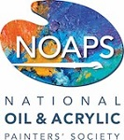

National Oil and Acrylic Painters’ Society

6th ‘Best of America’

Small Works Juried Exhibition

“BOULDER and BEYOND”
Plein Air (Open Air) Competition and Sale
and
Demonstration by Denise Antaya

Boulder, Colorado is nestled in the magnificent Rocky Mountain Front Range. It is the perfect balance of urban and outdoors.

Denise Antaya will kick off the competition with a plein air demonstration Wednesday, May 17th at 9:00 a.m.

Join us as we capture the energy of Boulder and the beauty of the mountains “en plein air”!

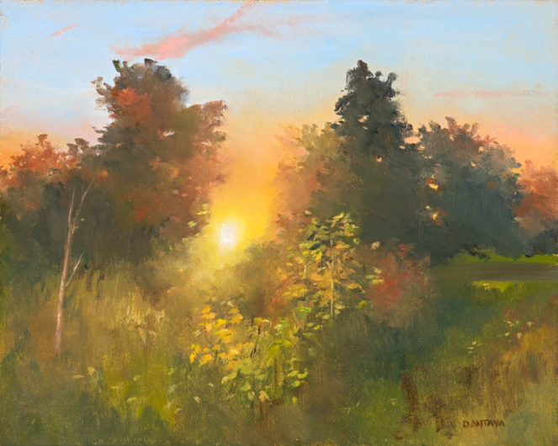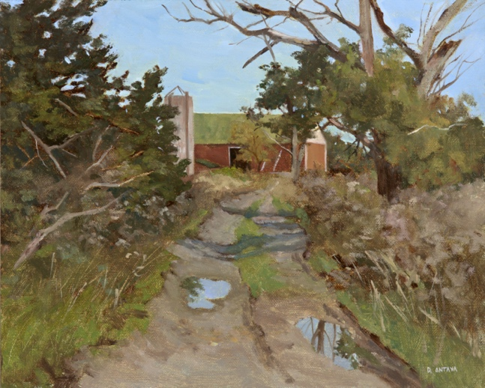
A B O U T T H E E V E N T
This two-day event is being held in conjunction with the NOAPS Best of America Small Works National Juried Exhibition at

Mary Williams Fine Arts – Boulder, Colorado
5311 Western Ave. #112, Boulder, CO

ARTIST ELIGIBILITY

(See Schedule Below)

Event is OPEN TO All Artists: 18 years of age or older
Dates: May 17 & 18, 2023 – Awards-May 19, 2023
Times: See Schedule below

Painting Delivery for Judging and Sale: May 19th, 9:00 am – Mary Williams Fine Arts (Bring your travel easel to display your artwork)

CASH AWARDS

First Place, Second Place and Third Place Awards
Announcement – Mary Williams Fine Arts – Friday, May 19, 2023 – 12:00 pm

PRE-REGISTRATION ENTRY FEE
NOAPS Members $20
Non-Members $50
New Membership & Entry Fee $62

- The 2023 annual membership is $52 and can be paid when entering this exhibit or through the Membership www.NOAPS.org/payment
- The ‘Best of America’ Small Works is a juried competition open to members of NOAPS.
ELIGIBILITY & ENTRY PROCESS
- Artwork should be painted outdoors from real life, without the use of photographs.
- Both painter and subject matter must be outdoors during the execution of the artwork.
- Artists may choose any subject matter outdoors within the Boulder area.
- This event will be held rain or shine, so come prepared!
- Blank canvas or boards must be stamped with the NOAPS stamp. (See Schedule Below)
- Artwork must be started and completed in its entirety May 17 and/or May 18, 2023.
- Artwork must be painted in Oils or Acrylics ONLY.
- Maximum painting size 320 square inches unframed​. Example: 16” x 20” = 320 sq. inches.
- The “NOAPS” stamp provided at registration must be visible on the back of each painting.
- All paintings must be framed and ready to hang for display. No exceptions.
- Artwork will be displayed for jurying and for sale at Mary Williams Fine Arts.
- One painting per artist guaranteed. Additional paintings may be allowed but the NOAPS Canvas Stamp must be present.
- Deliver Paintings: Paintings must be delivered to Mary Williams Fine Arts framed and ready to hang on Friday, May 19, 9:00 – 10:00 am. Bring your travel easel to display your paintings. All paintings must be framed, labeled, and wired for hanging. No exceptions.
- Painting Sale: Friday, May 19 and Saturday, May 20 from 10:00 am to the close of each business day.
- Painting Sale Proceeds – 55% Artist/45% Gallery.
- Pick up Paintings: Artists are responsible for picking up any unsold paintings Saturday afternoon, May 20 at 4:00 pm or by arrangement with the Gallery.
- NOAPS and Mary Williams Fine Arts assume no responsibility for theft, damage, or liability.
- Artists are responsible for insurance of his/her artwork.
- See Schedule Below
Plein Air Demonstration – May 17th – 9:00 am
DENISE ANTAYA
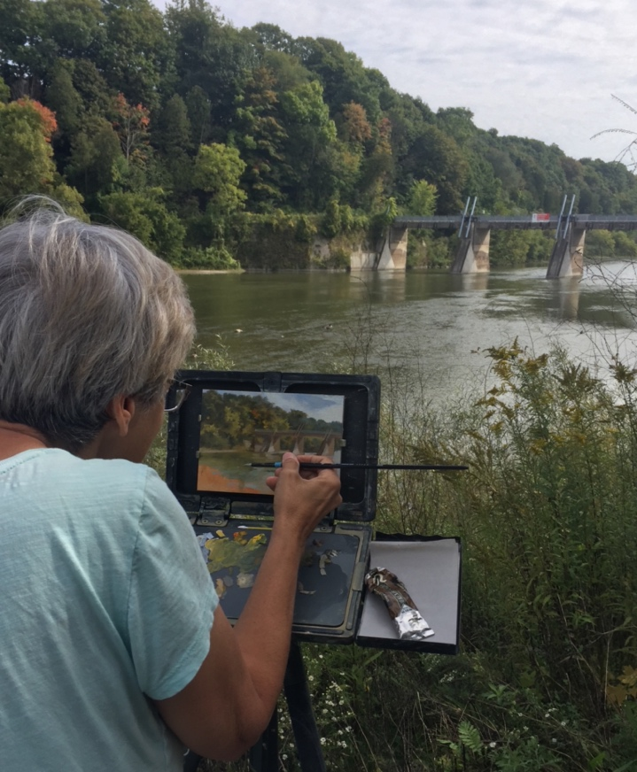
Denise Antaya Bio
Her roadmap to success avoids highways, and that’s the way she likes it.
Growing up in the country makes her appreciate the simple things, the beauty in nature. She didn’t spend her childhood on the highway, but back roads in the countryside, sometimes following a slow moving tractor. She took time to enjoy the sunshine, the surrounding fields, the shapes of the clouds in the sky. These are things that formed her love of landscapes. The everyday themes in Denise Antaya’s oil paintings combine her love of nature and her fascination with light and how it transforms an often overlooked scene. Her subjects range from season to season but almost always represent the natural environment untouched by man. She has the ability to capture a moment and even transport one back to a quieter, simpler time.
Her process starts with an underpainting, called a brunaille. It’s meticulously rendered, as the most important part of the process. Here the composition, value structure and drawing is sorted out, before the complication of colour is added. It’s a lot easier to change it at this stage in the process. No amount of paint can correct a bad drawing or poor composition. It’s the foundation needed to create a successful painting. Once she determines that everything is where it needs to be, she adds colour. Her plein air paintings work hand in hand with her studio work. Being out in nature where you see the nuances of colour help compensate for the drawbacks of photography when used.
To Antaya, painting the landscape is relevant. Everyone can appreciate nature, but it’s not the only reason she does this. It’s a way to document “how it was”. She loves the beauty of nature, unchanged by man, but the environment is being forever changed. Farms are being bought for development, old barns torn down, hundred year old trees disappearing. It’s a way to remember, often brings back simpler times when the world was not so fast paced. It’s a visual reminder of where we were, and also sometimes of where we are heading. The landscape is a never ending source of inspiration, one that will never end with its ever changing moods and complications. It’s a lifetime endeavour she hopes to never master!
“Boulder and Beyond”
Schedule
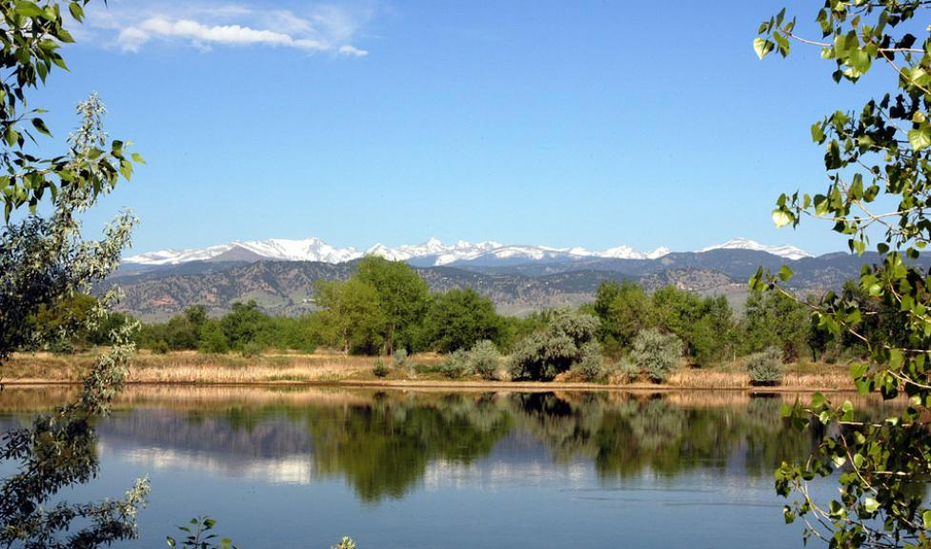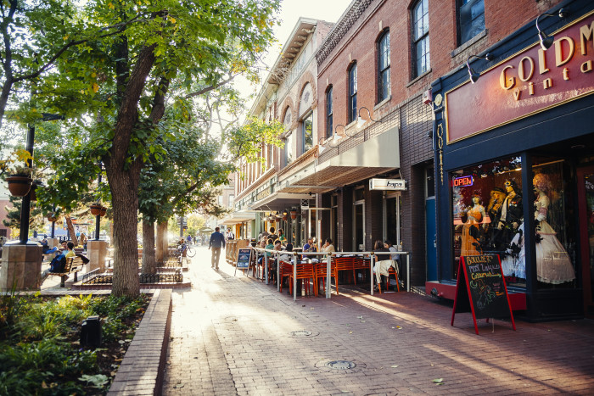
Questions: email – lisaprice1974@gmail.com or phone (205) 965-1505

Event Schedule: | Date | Time | Location
Registration and Canvas Stamp  (Site locations will be available) | Wednesday, May 17  Thursday, May 18 | 8:00 - 9:00 am  9:00 - 10:00 am | Sawhill Ponds, 3400 N. 75th Street, Boulder  Mary Williams Fine Arts
Denise Antaya Demonstration | Wednesday, May 17 | 9:00 – 11:00 am | Sawhill Ponds.
Enjoy Outdoor Painting  (Canvas MUST have NOAPS Stamp) | Wednesday, May 17  Thursday, May 18 | After demo – until  (Nocturns are welcome)  9:00 am – 3:00 pm | Locations within Boulder and surrounding area
Painting Delivery (Bring your easel to display your paintings) | Friday, May 19 | 9:00 am – 10:00 am | Mary Williams Fine Arts
Plein Air Awards and Refreshments | Friday, May 19 | 12:00 - 1:00 pm | Mary Williams Fine Arts
Painting Sale | Friday, May 19 &  Saturday, May 20 | 10:00 am - until close of business day | Mary Williams Fine Arts
Unsold Painting Pick up | Saturday, May 20 | 4:00 pm  (Or by arrangement with the Gallery) | Mary Williams Fine Arts

