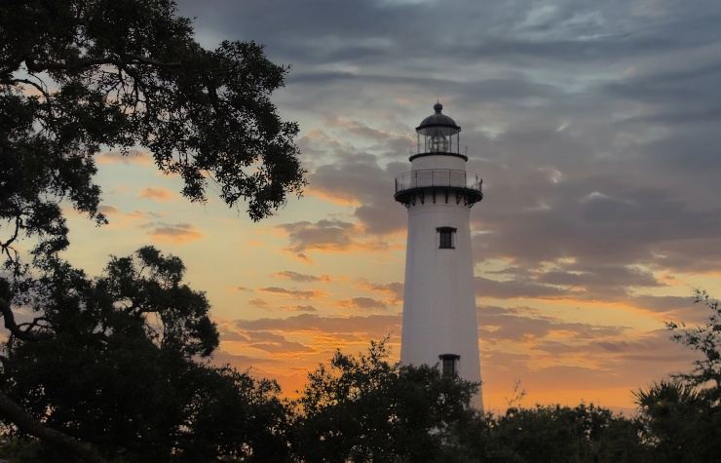
St. Simons Locations for NOAPS Plein Air
St. Simon’s Lighthouse (Public, Free) 610 Beachview Dr, St Simons Island, GA
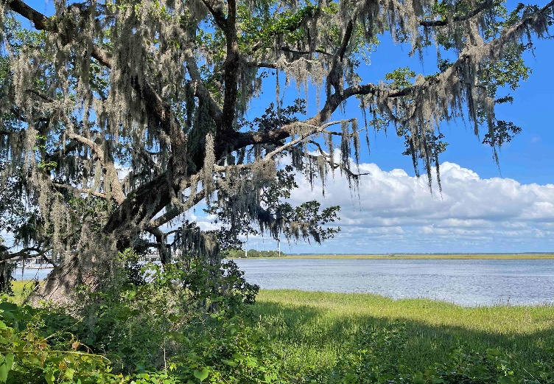
Gascoigne Bluff - (Public, Free) - 1000 Arthur J. Moore Dr., St. Simon’s Island, GA 31522
Located on the west side of St. Simons Island along the Frederica River, Gascoigne Bluff is a 24-acre park rich in history and scenic beauty. It serves as a popular public spot for fishing, picnics, and disc golf under historic live oak trees. Historically, it was a Native American site, a 1700s British naval base, a source of timber for the USS Constitution, and a plantation.

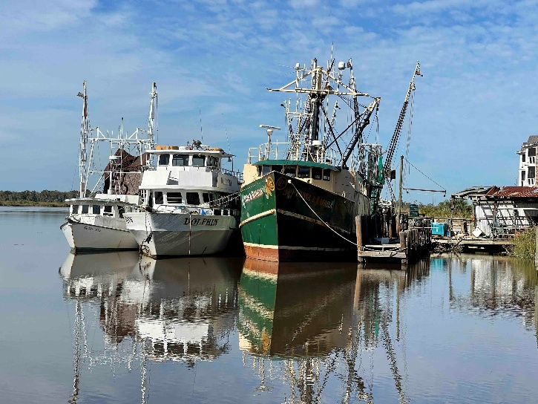
Shrimp boats in Darien, GA
Just over the bridge at 306 Fort King Dr, Darien, GA. This is the address for The Canopy restaurant. The shrimp boats are typically behind the restaurant down towards the bridge, although may be out shrimping. The town of Darien dates to pre-Colonial times, and there are some historic buildings left.

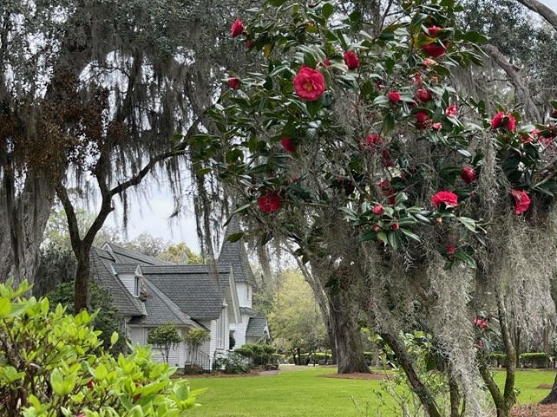
Christ Church Frederica
6329 Frederica Rd, St. Simons Island, GA 31522
The historic church is beautiful and surrounded by 300 year old live oaks.
Open 8-5

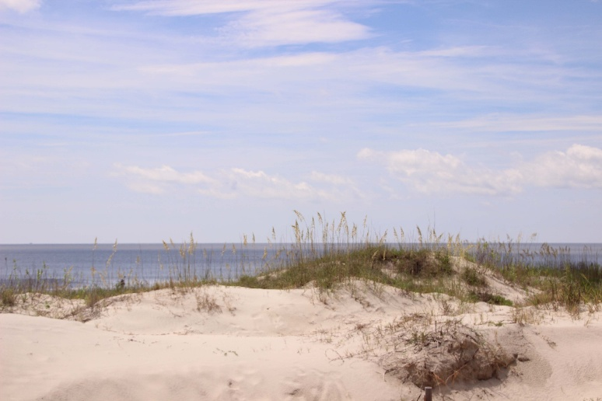
East Beach (Public Access) 4202 1st St., St Simons Island
Sandy, dog-friendly beach with sunbathing, swimming & water sports, plus showers & restrooms.

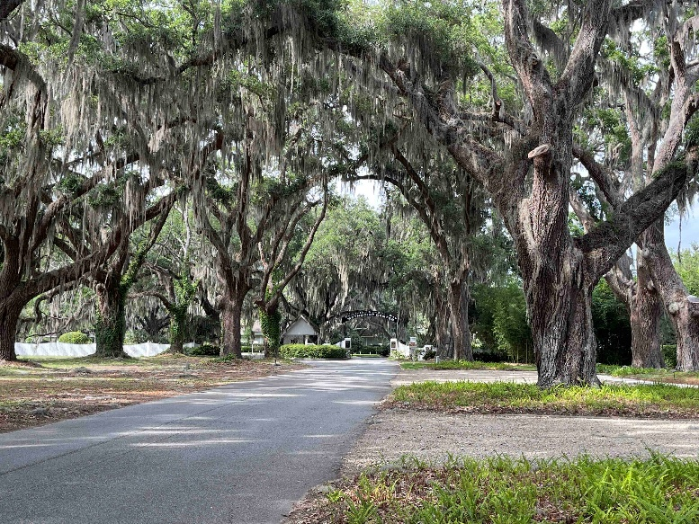
Epworth by the Sea
100 Arthur J Moore dr, St Simons Island, GA
Huge Live oaks on the marsh with some tabby buildings

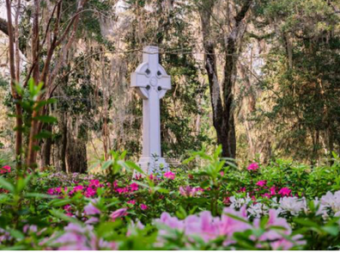
Wesley Memorial & Gardens
6510 Frederica Rd, St. Simons Island, GA
Wesley Gardens is located across the street from Christ Church. The grounds feature over 60 varieties of native plants and ancient live oaks draped in Spanish moss. An 18-foot Celtic Cross made of Georgia stone serves as the garden's centerpiece. Well-maintained pathways wind through the woods, connecting the gardens to other historic sites.
Hours: Dawn to Dusk Admission: Free Parking: At Christ Church Restrooms: Fort Frederica
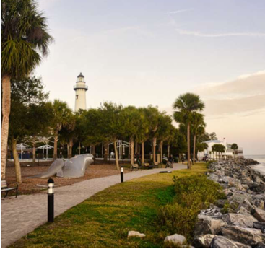
Neptune Park 550 Beachview Dr., St. Simons Island, GA
Neptune Park is located on the south end of Pier Village. There is a pier with a view of beautiful St. Simons Sound, the Lighthouse, etc.
Hours: 24 hrs. Parking: In the Area Restrooms: In the Area

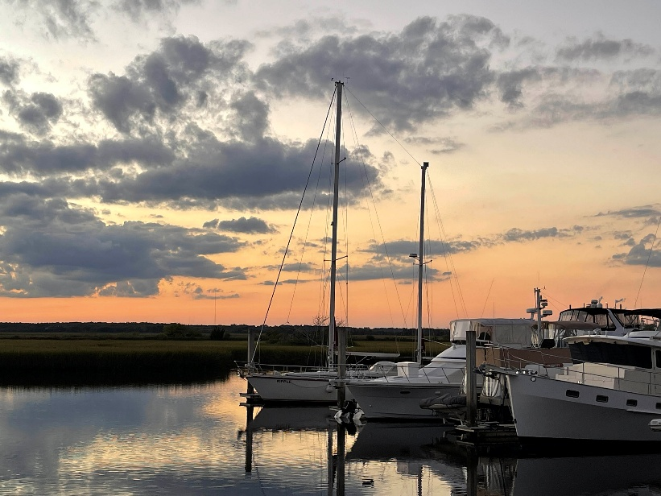
Sailboats at the Brunswick Landing Marina in Brunswick, GA
1 Torras Landing, Brunswick
Brunswick was recently voted “One of the 13 Prettiest Towns in the US” by WorldAtlas. There are Victorian buildings and Mary Ross park on the water with Public restrooms. The restrooms at the marina are not public.

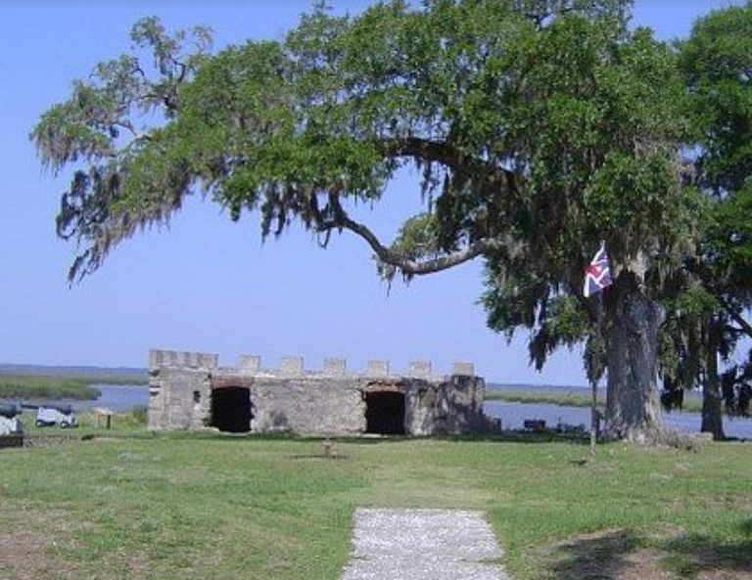
Fort Frederica National Monument
6615 Frederica Rd., St. Simons Island, GA
A British garrison founded by James Oglethorpe in 1736, open 9-5 with a Visitors center and restrooms.

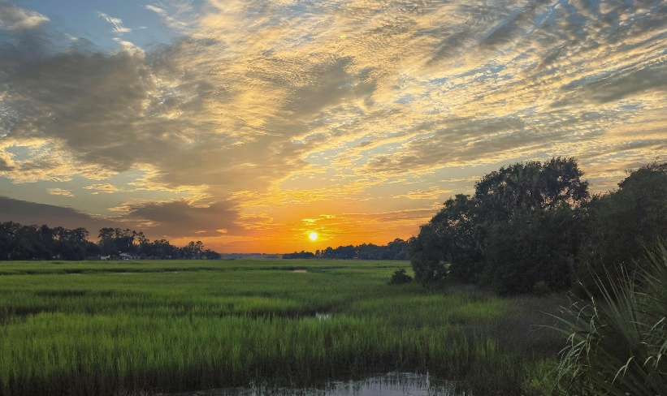

Sunsets/ Sunrises over the marsh
Gascoigne Bluff, Epworth by the Sea, or Bloody Marsh Park, site of a battle in 1742. 11806 Old Demere Rd, open 8:30 to 4, no restrooms.

Hofwyl- Broadfield Plantation This GA State Park includes an old house, out buildings and marsh views. There is a fee to enter. It’s on the right on US 17 on the way to Darien.
Morningstar Marina, 206 Marina Dr, Saint Simons Island, Ga, open 8-5. There’s a restaurant on the property. You’ll need to ask permission to paint here.
Gould’s Inlet (Public), 15th St. East Beach, St. Simons Island, GA There’s a nice view to Sea Island.
Bennie’s Red Barn – 5514 Frederica Rd, St Simons Island, GA Painting should end before the restaurant opens at 5:00. The iconic red barn itself, the surrounding oak trees, and the rustic, historic, and often quaint surroundings.

