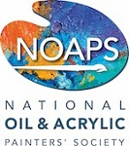

National Oil and Acrylic Painters’ Society

9th Annual Best of America

Small Works International Juried
Exhibition

“Paint St. Simons Island”
St. Simons Island, Georgia Plein Air (Open Air) Competition and Sale
April 29th and 30th, 2026

St. Simons Island, a breathtaking jewel on the Georgia coast, beckons artists and travelers alike to a true painter's paradise. Immerse yourself in a landscape where scenic beaches melt into serene marshes, and charming coastal towns offer endless inspiration around every corner. We invite you to capture the island's unique light and character during the ultimate plein air adventure:
"Paint St. Simons Island"
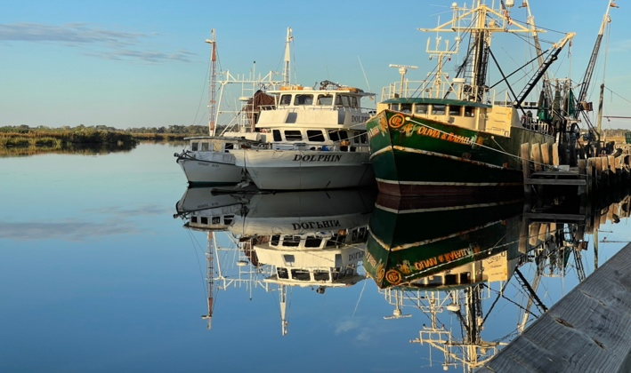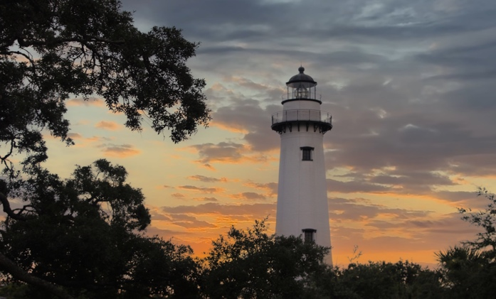
A B O U T T H E E V E N T
This two-day event is being held in conjunction with the NOAPS Best of America Small Works International Juried Exhibition at

Anderson Fine Art Gallery
3309 Frederica Road
St. Simons Island, GA 31522
ARTIST ELIGIBILITY
(See Schedule Below)

Event is OPEN TO ALL ARTISTS: 18 years of age or older
Date: April 29th & 30th, 2026 – Awards – May 1st, 2026
Time: See Schedule below

Painting Delivery for Judging and Sale: May 1st, 8:30 am – Anderson Fine Art Gallery
(Bring your travel easel to display your artwork)

CASH AWARDS
First Place - $1000
Second Place - $500
Third Place - $250
Announcement – Friday, May 1st, 2026 – 1:00 pm

REGISTRATION ENTRY FEE
$20 for Members and Non-Members
(If you’re a Non-Member, we invite you to join us!)

- To Join NOAPS, the 2025 annual membership is $62 and can be paid through the Membership: www.NOAPS.org/payment

- The ‘Best of America’ Small Works is a juried competition open to members of NOAPS.
ELIGIBILITY & ENTRY PROCESS
- Artwork should be painted outdoors from real life, without the use of photographs.
- Both painter and subject matter must be outdoors during the execution of the artwork.
- Artists may choose any subject matter outdoors within St. Simons Island and the surrounding area.
- This event will be held rain or shine, so come prepared!
- Blank canvas or boards must be stamped with the NOAPS stamp. (See Schedule Below)
- Artwork must be started and completed in its entirety April 29 and/or April 30, 2026.
- Artwork must be painted in Oils or Acrylics ONLY.
- Maximum painting size 320 square inches unframed​. Example: 16” x 20” = 320 sq. inches.
- The “NOAPS” stamp provided at registration must be visible on the back of each painting.
- All paintings must be framed and ready to hang for display. No exceptions.
- Deliver Paintings: Paintings must be delivered to Anderson Fine Art Gallery, framed and ready to hang, on Friday, May 1st, 8:30 – 9:30 am. Bring your travel easel to display your paintings. All paintings must be framed, labeled, and wired for hanging. No exceptions.
- Artwork will be displayed for jurying and for sale at Anderson Fine Art Gallery.
- All paintings are eligible for judging but only one painting per artist will be displayed in the gallery.
- Painting Sale: Friday, May 1st until pick up on Saturday, May 2nd.
- Painting Sale Proceeds – 55% Artist / 45% Gallery.
- Pick up Paintings: Artists are responsible for picking up any unsold paintings Saturday afternoon,
May 2nd at 3:00 pm or by arrangement with the Gallery.
- NOAPS and Anderson Fine Art Gallery assume no responsibility for theft, damage, or liability.
- Artists are responsible for insurance of his/her artwork.
- See Schedule Below
“PAINT ST. SIMONS ISLAND” PLEIN AIR
Schedule
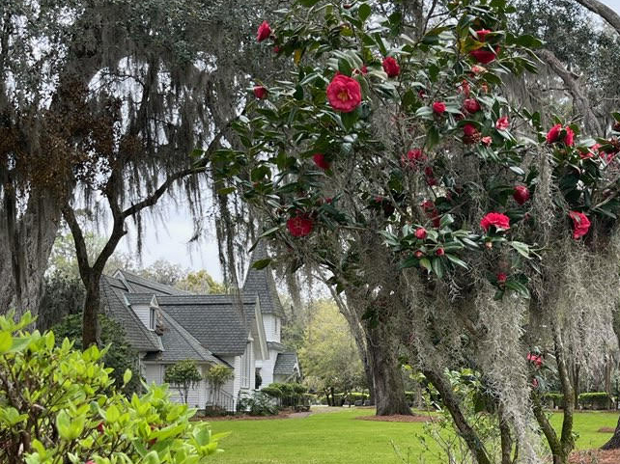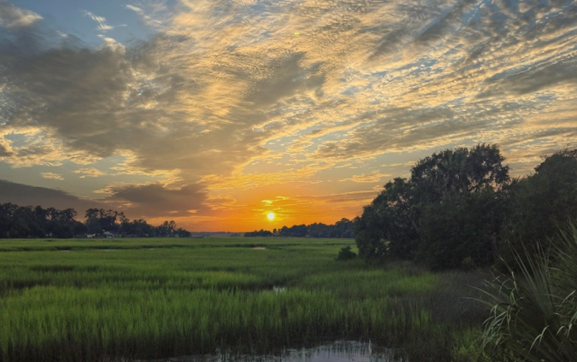
To Sign up or for Questions: email – jillmcgannon@gmail.com

Event Schedule | Date | Time | Location
Registration and Canvas Stamp  (Suggested site locations will be available) | Wednesday, April 29  Thursday, April 30 | 8:30 - 9:30 am  8:30 – 9:30 am | Anderson Fine Art Gallery  3309 Frederica Rd,  St Simons Island, GA 31522
Enjoy Outdoor Painting  (Canvas MUST have NOAPS Stamp) | Wednesday, April 29  Thursday, April 30 | 8:30 – until  (Nocturns are allowed)  8:30 am – until  (Nocturns are allowed) | Locations in St. Simons Island and the surrounding area
Painting Delivery (Bring your easel to display your paintings) | Friday, May 1 | 8:30 am – 9:30 am | Anderson Fine Art Gallery
Luncheon and Awards | Friday, May 1 | 12:00 pm (Luncheon)  1:00 pm (Awards) | Anderson Fine Art Gallery
Painting Sale | Friday, May 1 &  Saturday, May 2 | 10:00 am - until close of business day | Anderson Fine Art Gallery
Unsold Painting Pick up | Saturday, May 10 | 3:00 pm | Anderson Fine Art Gallery

